Mr A G Lawrence,  Clerk to Newhall Parish Council  THE WOODLANDS  WHITCHURCH ROAD  ASTON  NANTWICH  CW5 8DB | Development Management  PO Box 606  Municipal Buildings  Earle Street  Crewe  CW1 9HP  Telephone: 0300 123 5014  E-Mail: planning@cheshireeast.gov.uk

Dear Sir/Madam | Date: 21-Jul-2016

TOWN AND COUNTRY PLANNING ACT 1990
Notification under Terms of Article 8, Schedule 1 Concerning a Planning Application

Application No: | 16/3507N
Proposal: | Conversion of existing traditional farm buildings at Hollin Green Farm to form four residential units. Complete with new access, associated parking, turning and landscaping.
Location: | HOLLIN GREEN FARM, HOLLIN GREEN LANE, NEWHALL, NANTWICH, CHESHIRE, CW5 8AZ
National Grid Ref: | 363676 345281

The application form and plan(s) relating to this application are available for viewing online By Clicking Here

Under the terms of current legislation, the Council is permitted a period of eight weeks in which to determine this application. For your views to be considered I need to receive them by 25-Aug-2016. In order to aid our electronic processes please email your comments to planning@cheshireeast.gov.uk. ANY COMMENTS MUST BE CONTAINED WITHIN THE EMAIL AND NOT SUBMITTED AS AN ATTACHMENT. YOUR ASSISTANCE IN PROVIDING COMMENTS IN THIS FORMAT IS APPRECIATED.

The application is scheduled to be determined under delegated powers. The last date for a Councillor to call the application to a planning committee is 12 August 2016

Once a decision has been made on the application, the decision will be posted on the Planning pages of our website www.cheshireeast.gov.uk where you will also be able to view a copy of the Decision Notice.

Yours faithfully

Head of Planning (Regulatory)

Note:
This letter has been produced by Civicance Ltd on behalf of Cheshire East Development Management.

For any Development; Planning permission is only the start of the process. Proposals may also require permission and inspection under the Building Regulations 2010 (as amended).

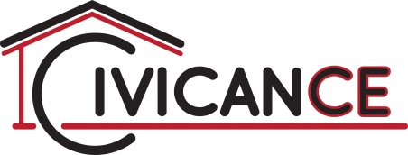
Civicance Limited are the only Building Regulation service provided on behalf of Cheshire East Council, providing a clearly independent third party check, ensuring your property is safe and energy efficient for years to come. For all enquiries please phone: 01270 375256 or 01270 686799

